**CONTENTS**

CERTIFICATE I

DECLARATION II

ACKNOWLEDGEMENT III

LIST OF FIGURES IV

LIST OF TABLES V

**CHAPTER TITLE PAGE NO**

**1 INTRODUCTION** **2**

* 1. BACKGROUND 2
  2. PROBLEM DEFINITION 2
     1. SOFTWARE REQUIREMENT SPECIFICATION 3
     2. PROJECT PLAN 4

1. **PROJECT ANALYSIS 5**
   1. DFD LEVEL 0 5
   2. DFD LEVEL 1 5
   3. WORK FLOW DIAGRAM 6
2. **PROJECT DESIGN 7**
   1. DESIGN MODULE 7
3. **PROJECT IMPLEMENTATION & CODING 8**
   1. GUI IMPLEMENTATION 8
   2. CODE DETAILS 21
4. **PROJECT TESTING 40**
   1. UNIT TESTING 40
   2. SYSTEM TESTING 41
5. **CONCLUSIONS 42**
6. **BIBLIOGRAPHY 42**
7. **INTRODUCTION**

We, the eager-learners of Diploma in Computer Technology developed a simple Learning application for the kids of pre-schooling i.e. for pre-primary students. The kids learning application of ours’ focuses mainly to attract the kids more and more by the features we have added in it by all our strengths. We have done this project successfully under the guidance of our very co-operative staff in-charge Mrs. Trigule D.J. Our application maximum tries to gain the attention of kids by the realistic pictures, sounds, animations, videos, etc. Though there are many learning applications available in the market but we developed our application in such a way that it will surely compete with most of the applications at this level. When our entire team was in confusion in making a decision to develop any learning application then the first and foremost idea clicked into our brains was developing a ‘C’ programming application. So, our guide suggested that a learning application for kids will stand strong because many of them say that “If the base anything is strong then the future will also be strong.” So, that was the reason we started building this learning application for the kids to make them sharp before going to schools.

1.1 BACKGROUND

There’s a strong and reasonable motive behind developing such application is to make a kid sharp before entering his higher school. This is because as we know that whatever we provided in our application is available in the books, magazines, charts, etc. But we know that a kid’s brain is not so matured and isn’t concentrated at a same thing for a period of time. To fix this problem, we tried to teach them by our application through beautiful and attractive interfaces. As we know that now-a-days, each and every kid is attracted to electronic devices like the computers, tablets, laptops and mobile devices. The basic motive behind developing our project is “We knew at the beginning that any kid learns faster by hearing.” Because we know that a kid identifies a cow, cat, dog in his daily life by their cry. So we not only added the images of the animals and birds but also added their realistic cries. We also added colors, rhymes, activities in our project to test their kids from their parents. Because, a learning application not only focuses on teaching but also enables the learners to test themselves. The first doubt that comes into the user’s mind after accessing the activity section of our application is that all the questions are in the text format and the kid at that age is not able to read them. So by taking all the care of each kid who learns through our application, we fixed this problem. We first displayed the simple questions in bold and then when a kid clicks on that particular question then he/she can hear it and can answer that question easily. This feature is added for the correct and wrong answers also.

1.2 PROBLEM DEFINTION

As we have handled the on click events of each and every control in our application, we have added the sounds clips for every control for better and attractive learning for the kid. We aren't satisfied with whatever we have done we want to achieve the animation when a kid clicks on a control like any animal or any bird if suppose a kid clicks on a cat then now in current state, only the cry of that cat is visible or heard. But in addition, we want animation with this all. Another problem definition in our application is that we have added the most popular rhymes for the kids but the problem comes about the internet connectivity. Our application requires the internet connectivity only when a kid wants to hear or see the rhymes not for all other controls. Quite faster internet connectivity fixes this problem but as you know that there is an internet connectivity problem at many regions so, this is a problem for our application and we will try to solve it as soon as possible for the kid’s betterment. We have added a questionnaire for the kids at the end. Though we have added the questions and answers in a simple but effective way but still we are in satisfied with that each and every question should be of animated type so the kid will get attracted to the application and spends more and more time and also become sharper.

1.2.ASOFTWARE REQUIREMENT SPECIFICATION

* Operating System : Windows
* RAM : 8GB
* HDD : 1TB
* Database : None
* Software : Android Studio
* Emulator : Android
* Java Development Kit (JDK) : Java 17.0.2
* Software Development Kit (SDK) / API Level : Level 30

1.2.BPROJECT PLAN

Tab1.1 PROJECT PLAN

|  |  |  |
| --- | --- | --- |
| Sr.  No. | Week no. | Actual work done |
| 1 | Sep 1st week | Group members were selected and finalized. |
| 2 | Sep 2nd week to 4th week | Browsed for a suitable, helpful and desired topic. |
| 3 | Oct 1st week to 2nd week | Separate work assignment was given to each team member. |
| 4 | Oct 3rd week to Nov 2nd week | Drawn the imaginary outline structure of the application. |
| 5 | Nov 3rd week to 4th week | Defined problem definition and survey questions were collected. |
| 6 | Dec 1st week to 2nd week | Gathered all the hardware and software requirements required for the project. |
| 7 | Dec 3rd week & 4th week | Submitted entire plan’s report with all specified points. |
| 8 | Feb 2nd week to 3rd week | Designed the structure of project and Properly self-assessed the structure of project. |
| 9 | Feb 4th week | Implemented required and desired functionalities in the application. |
| 10 | Mar 1st week & 2nd week | Designed the activity diagram. |
| 11 | Mar 3rd week & 4th week | Implemented front-end activity. |
| 12 | Apr 1st week to 4th week | Developed the application in Android Studio by taking required references. |
| 13 | May 1st week | Added some extra features for every interface of the application. |
| 14 | May 2nd week | Properly tested the application. |

1. **PROJECT ANALYSIS**
   1. DFD level 0

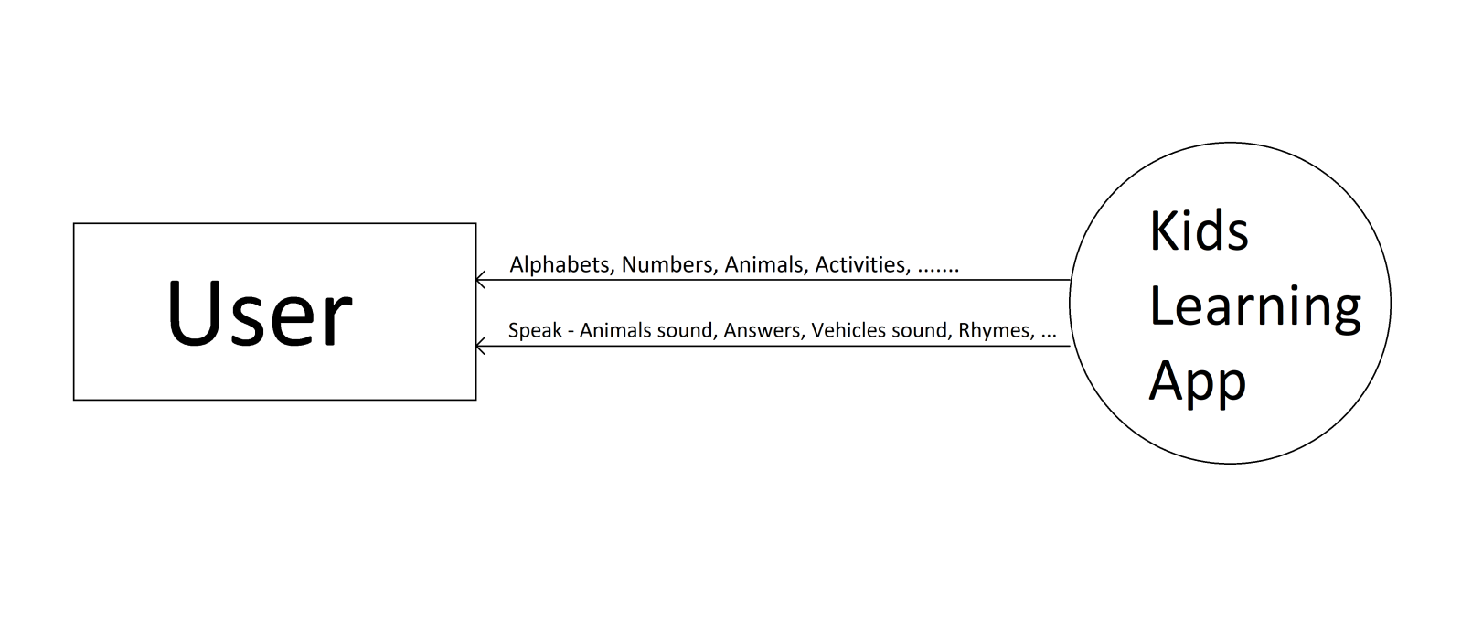

* 1. DFD level 1

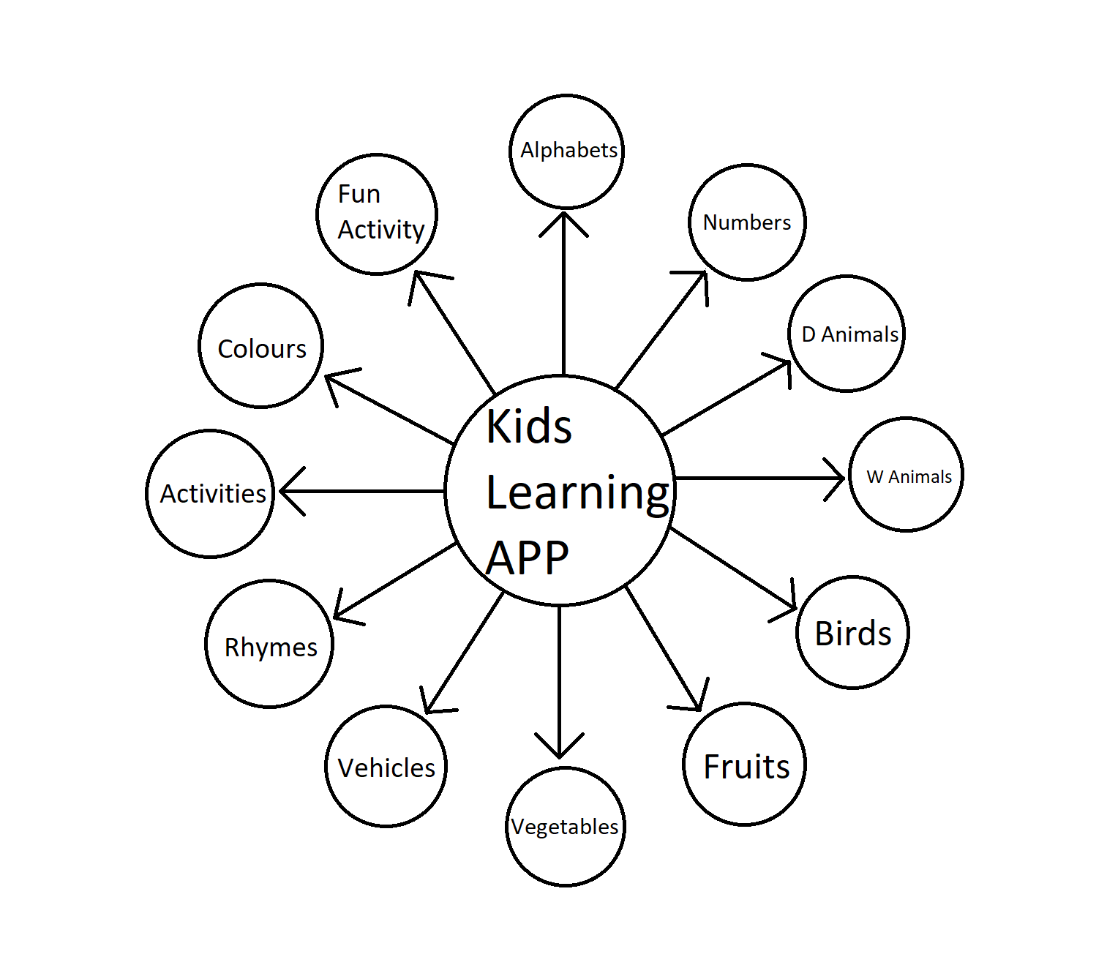

* 1. Work Flow Diagram

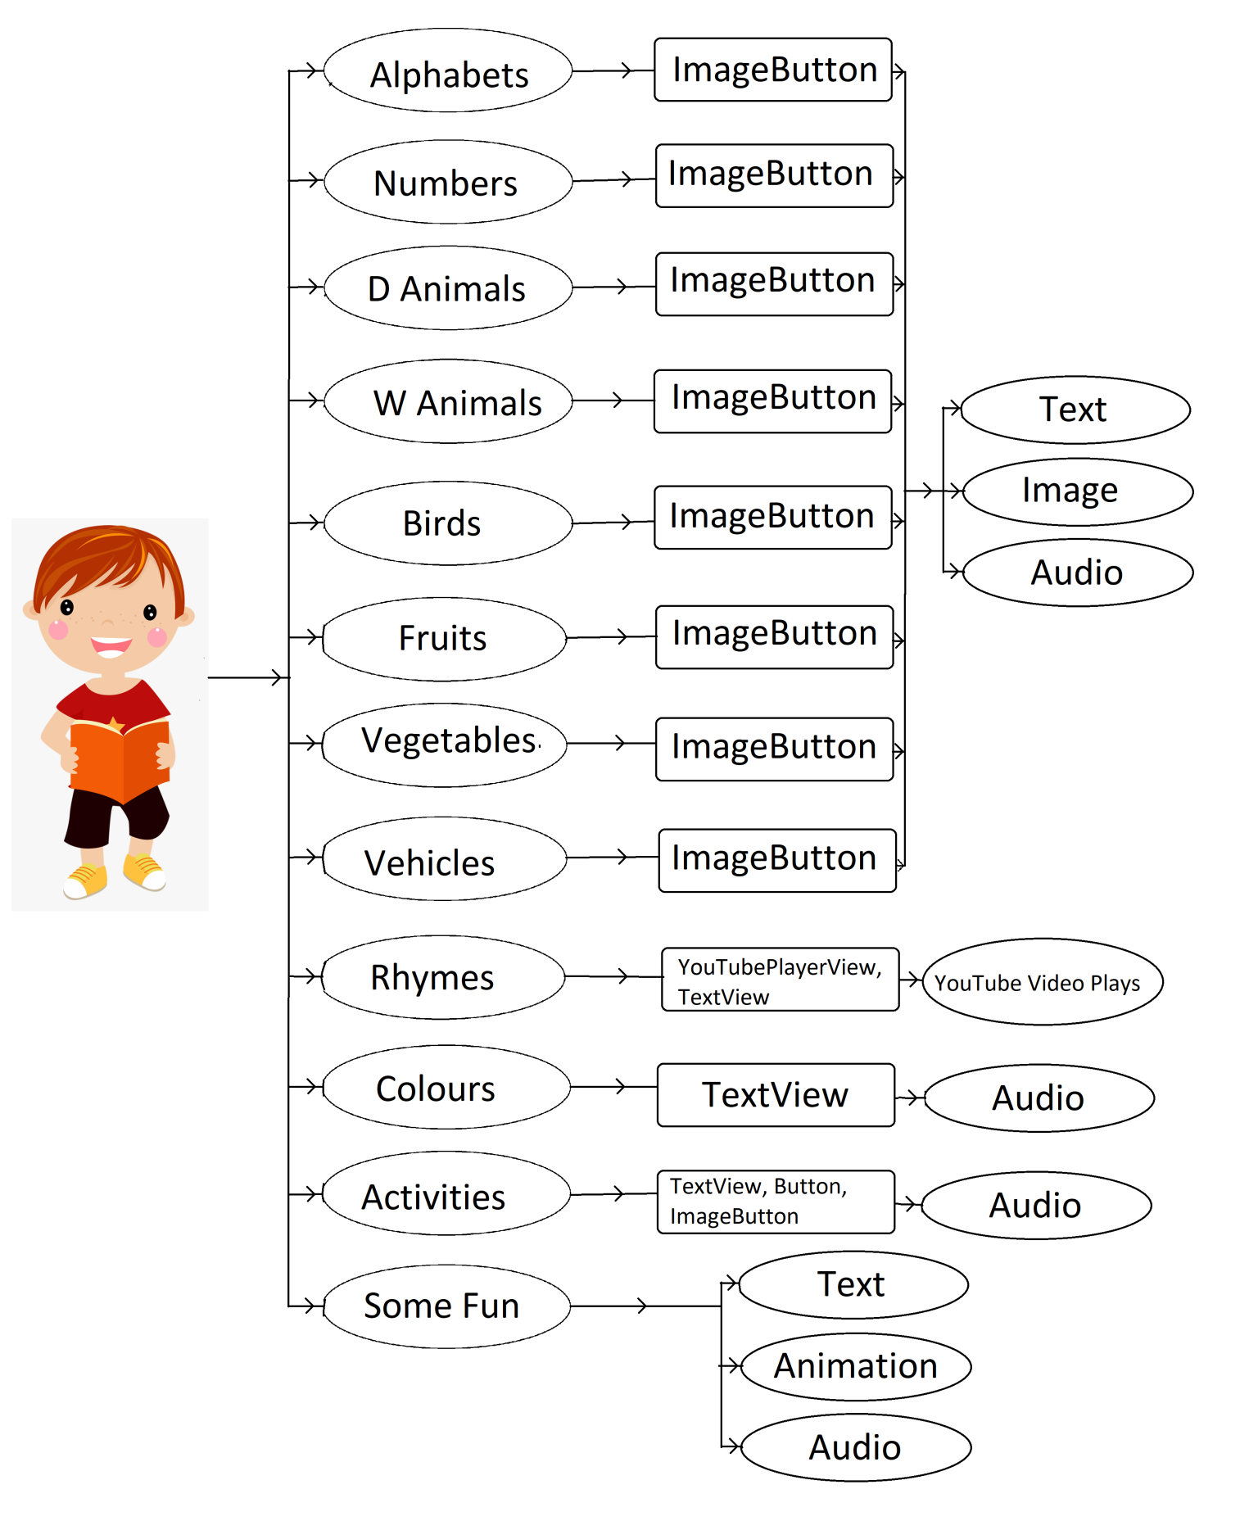

1. **PROJECT DESIGN**

3.1 DESIGN MODULE

a. Alphabets :

here all alphabets are displayed.

b. Numbers :

here ten numbers are displayed.

c. Domistic Animals :

here Domestic Animals are displayed

d. Wild Animals :

here Wild Animals are displayed.

e. Birds :

here Birds are displayed.

f. Fruits :

here Fruits are displayed.

g. Vegetables :

here Vegetables are displayed.

h. Rhymes :

here Rhymes are displayed.

i. Colours :

here Colours are displayed.

j. Activities :

here some Activities(quiz and answer ) are taken.

k. Tricky,Fun,Craze :

here we dsplayed some animation and gif’s.

1. **PROJECT IMPLEMENTATION & CODING**
   1. GUI IMPLEMENTATION

Fig 4.1 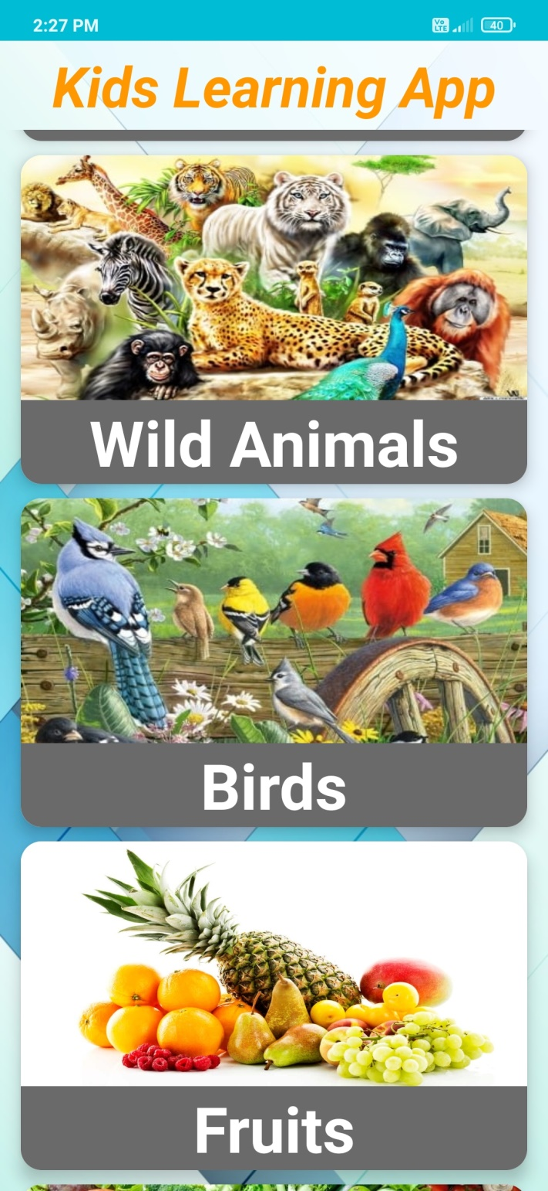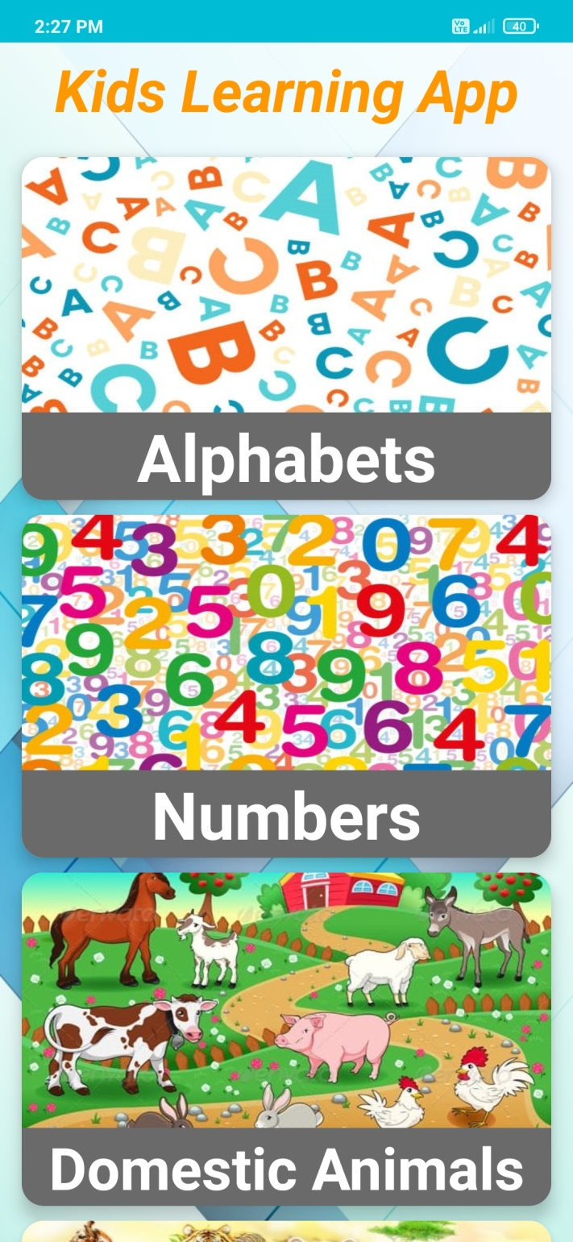Main Screen 1 Fig 4.2 Main Screen 2

Fig 4.3 Main Screen 3 Fig 4.4 Main Screen 4

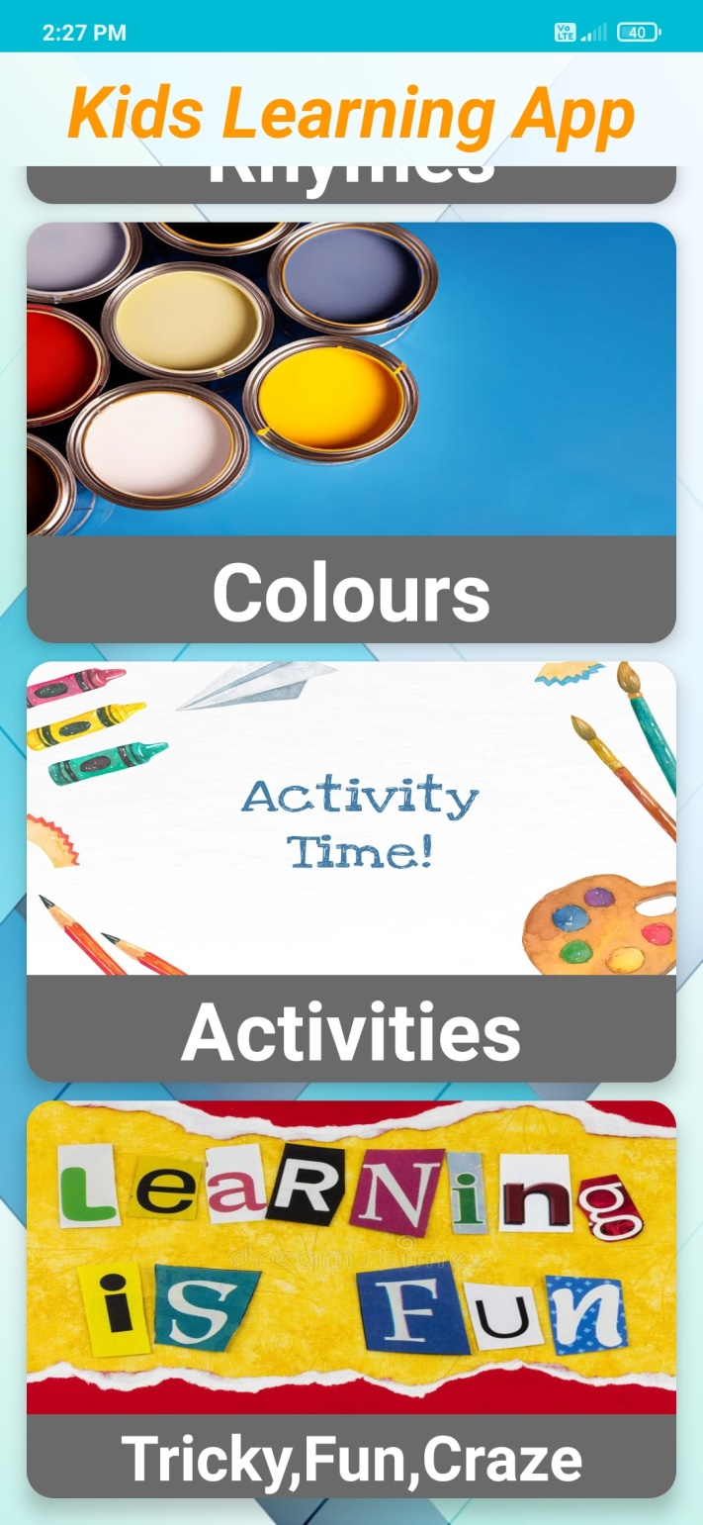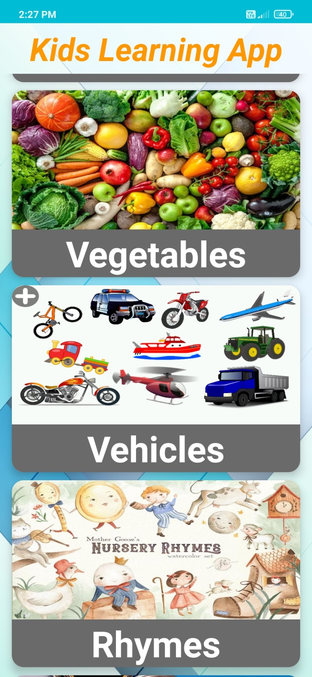

Fig 4.5 Alphabets Fig 4.6 Numbers

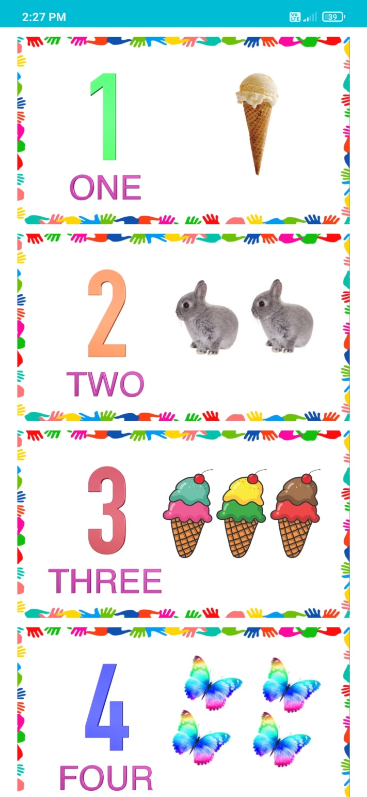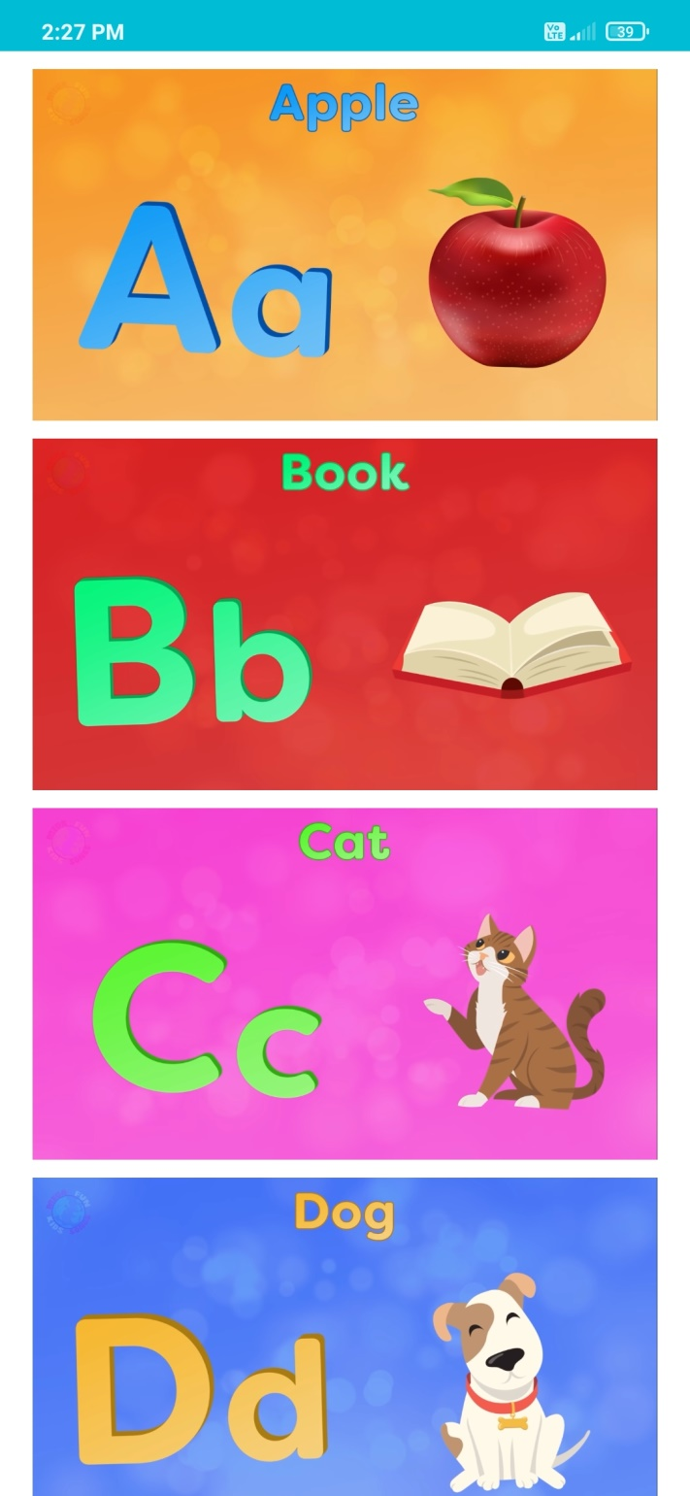

Fig 4.7 D Animals Fig 4.8 W Animals

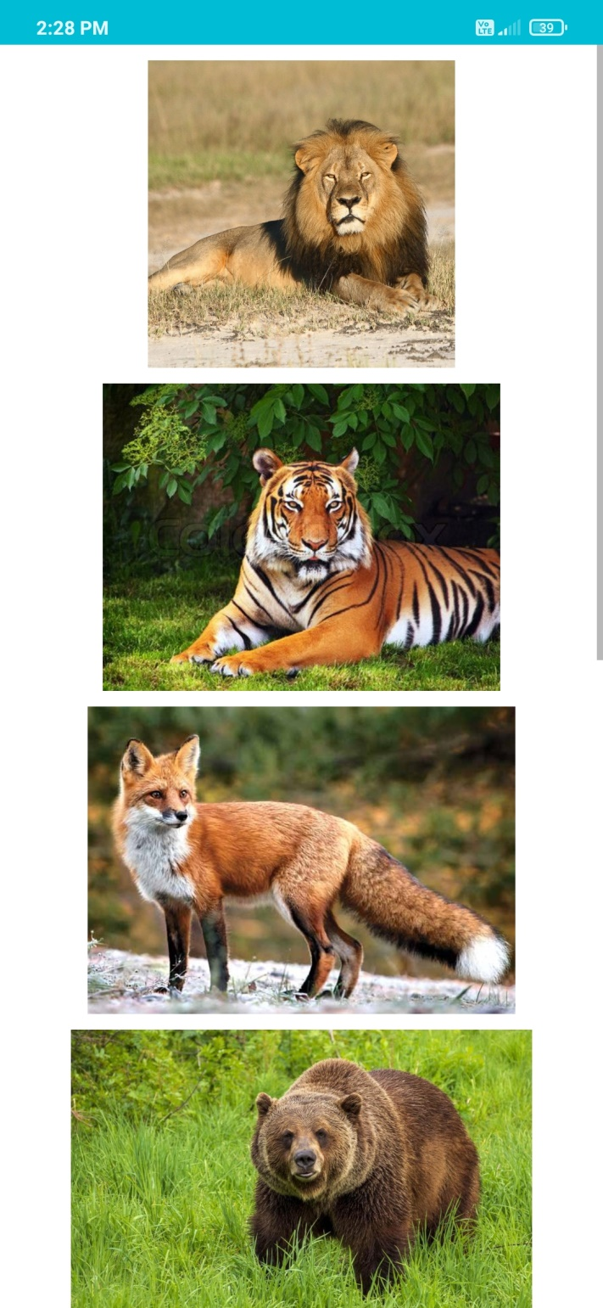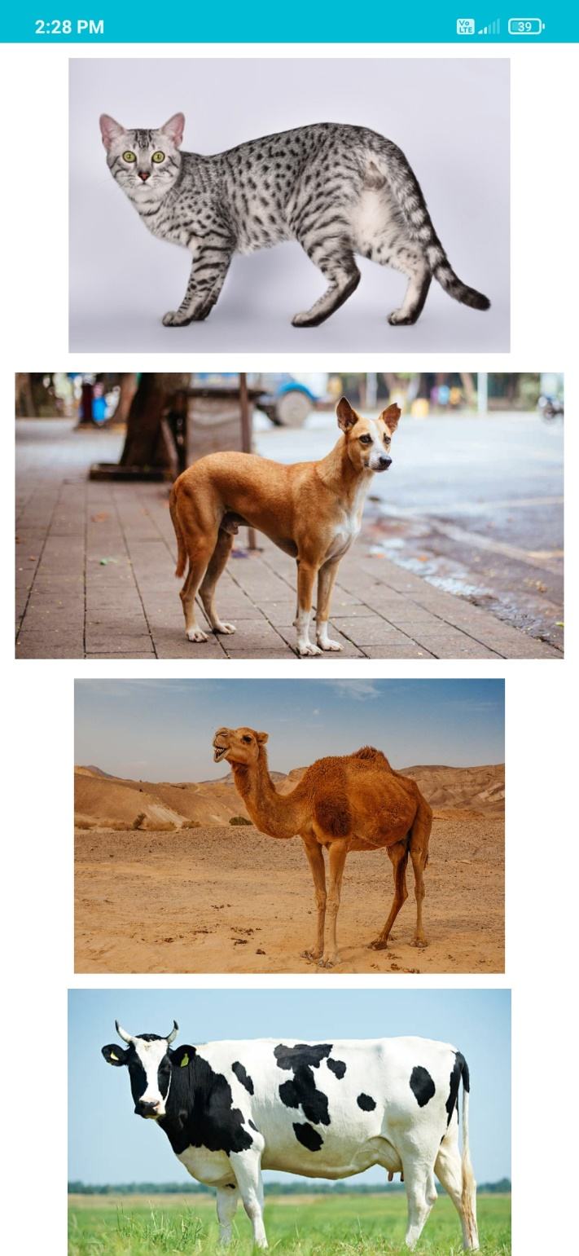

Fig 4.9 Birds Fig 4.10 Fruits

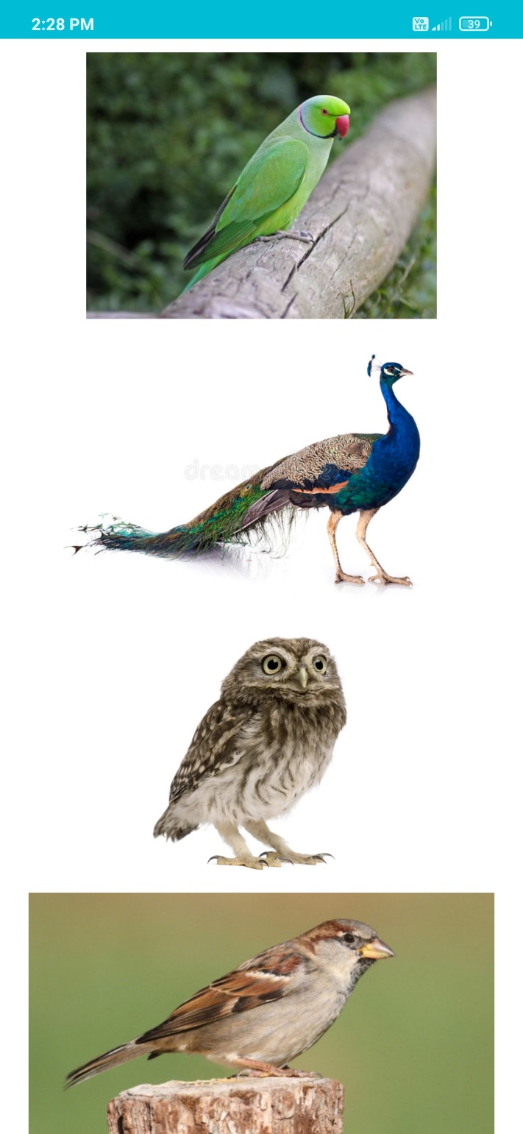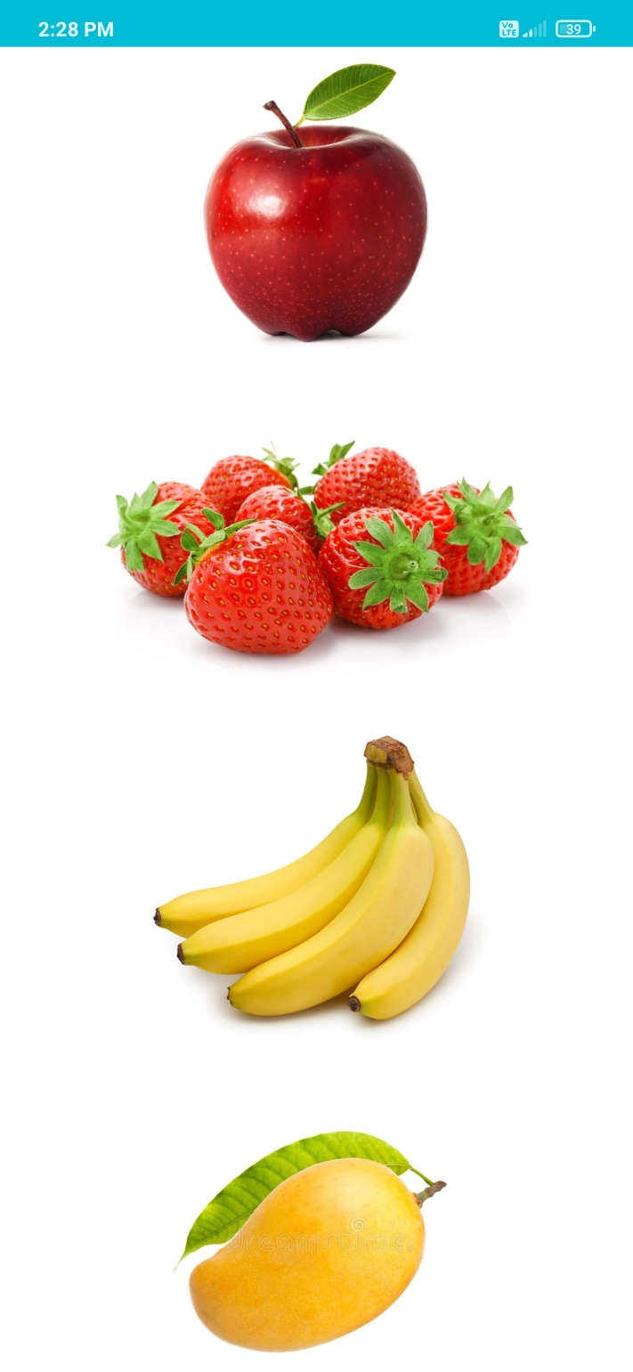

Fig 4.11 Vegetables Fig 4.12 Vehicles

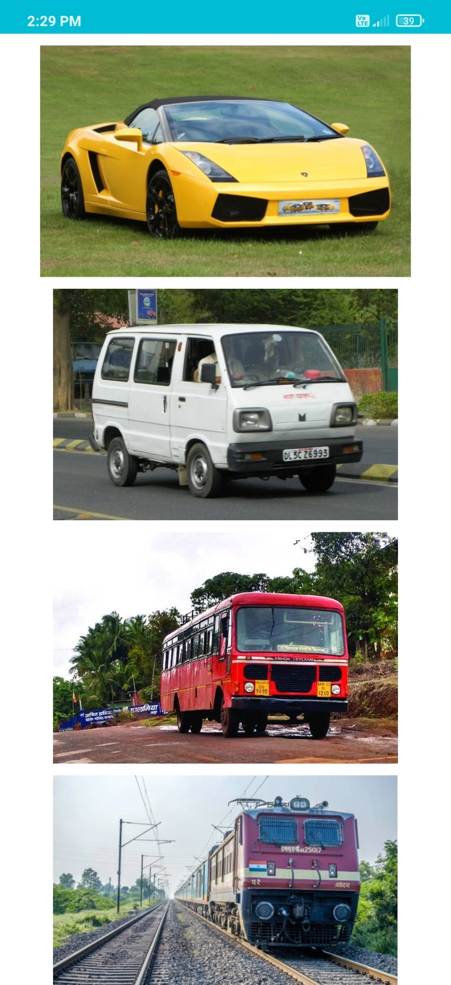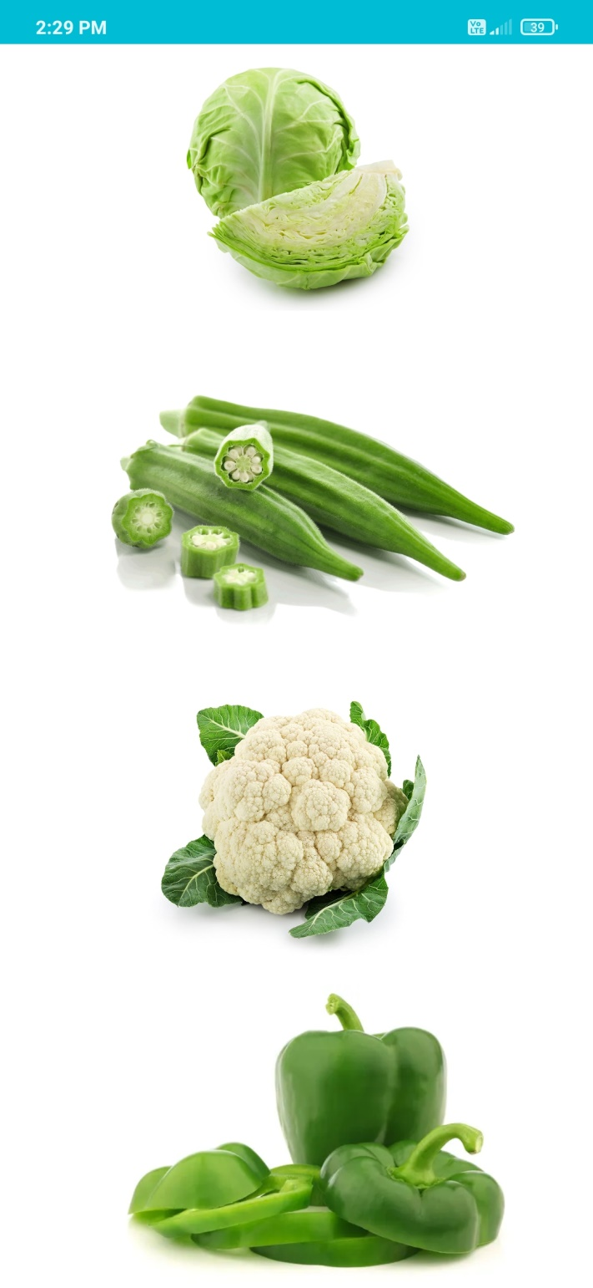

Fig 4.13 Rhymes Fig 4.14 Colours

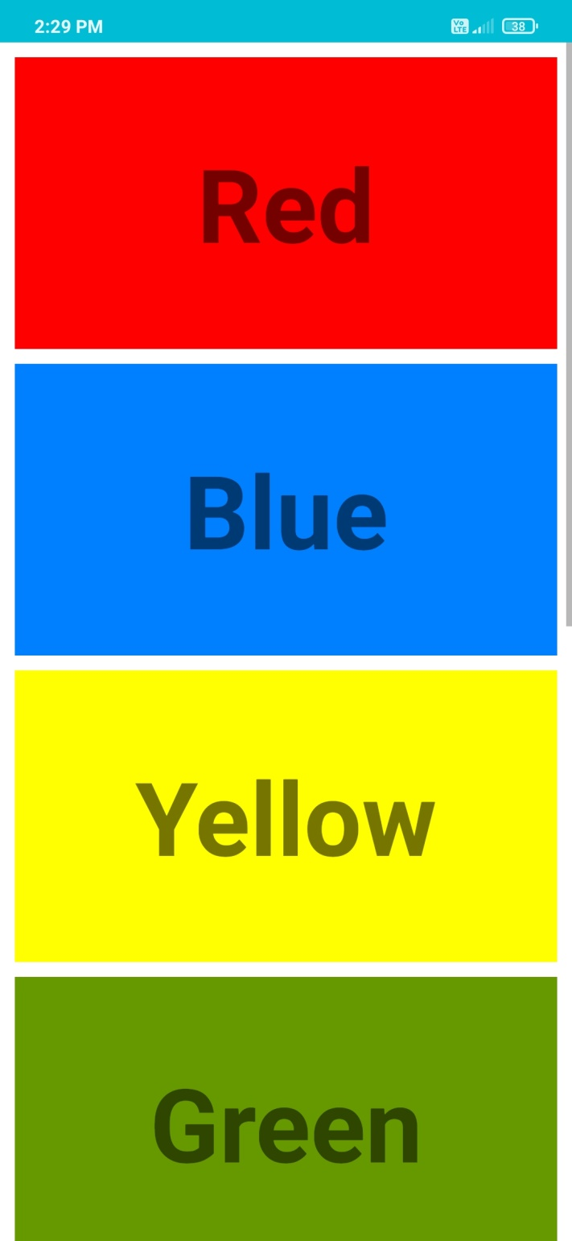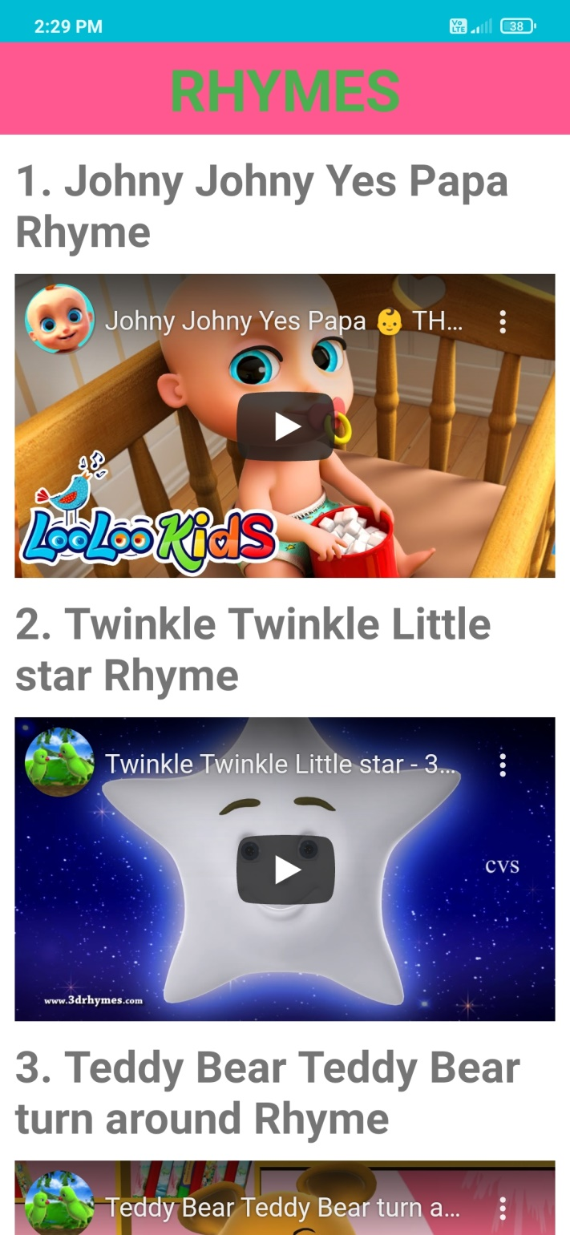

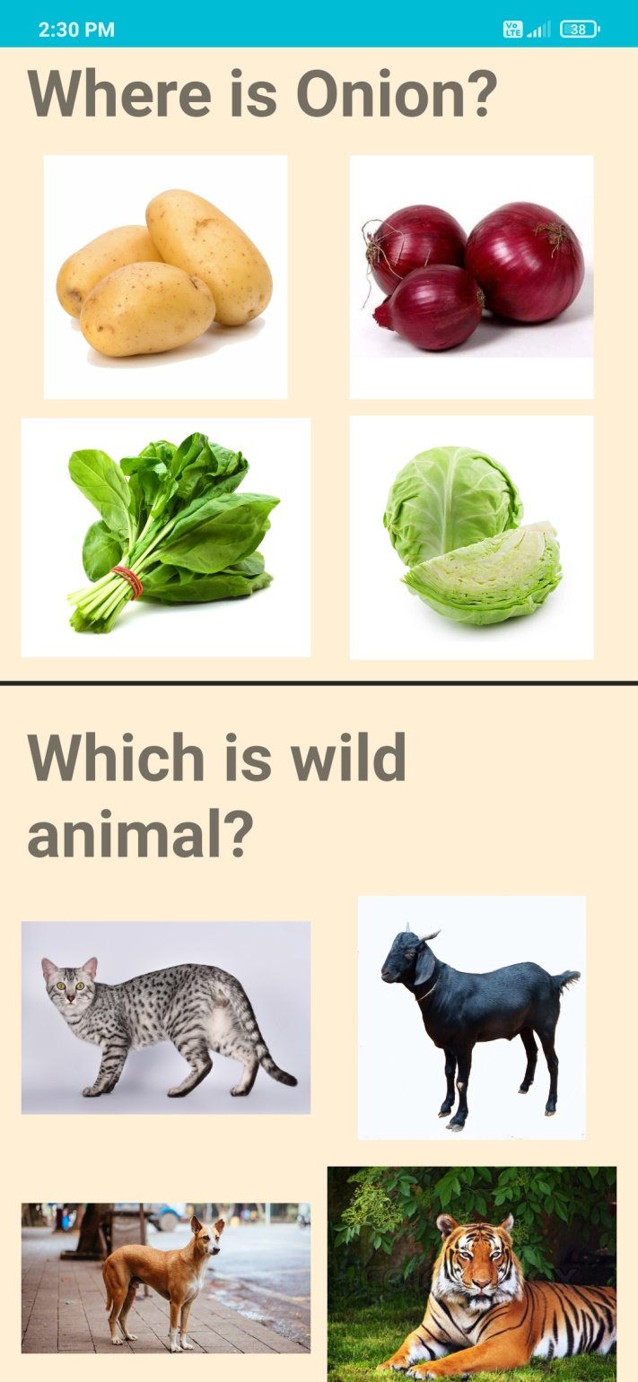 Fig 4.15 Activities screen 1 Fig 4.16 Activities screen 2

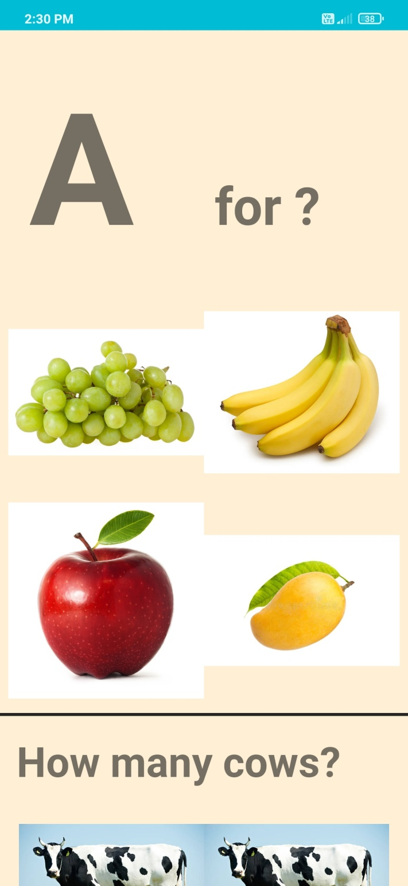

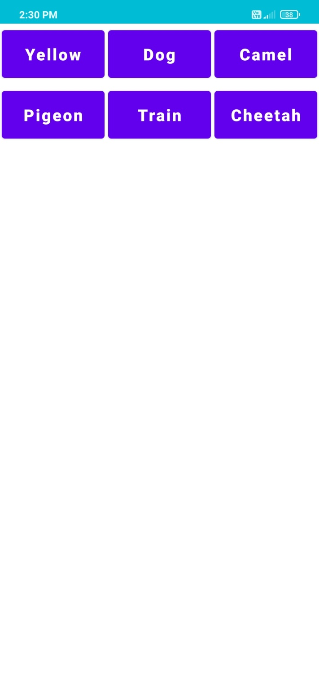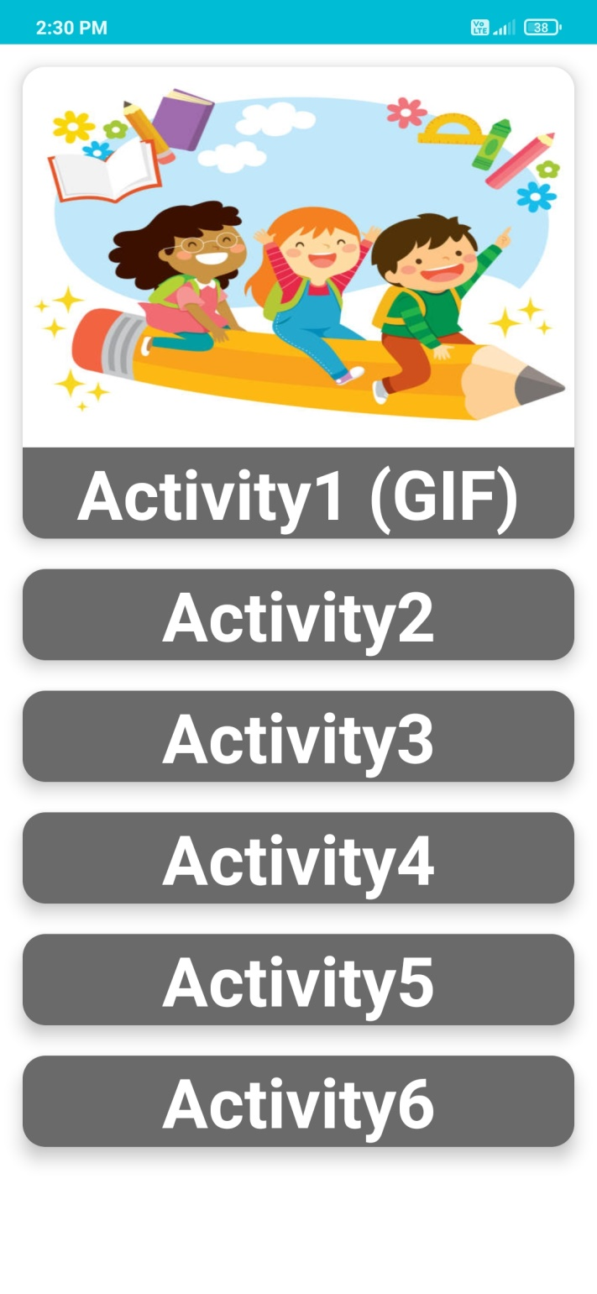 Fig 4.17 Tricky,Fun,Craze Fig 4.18 GIF screen 1

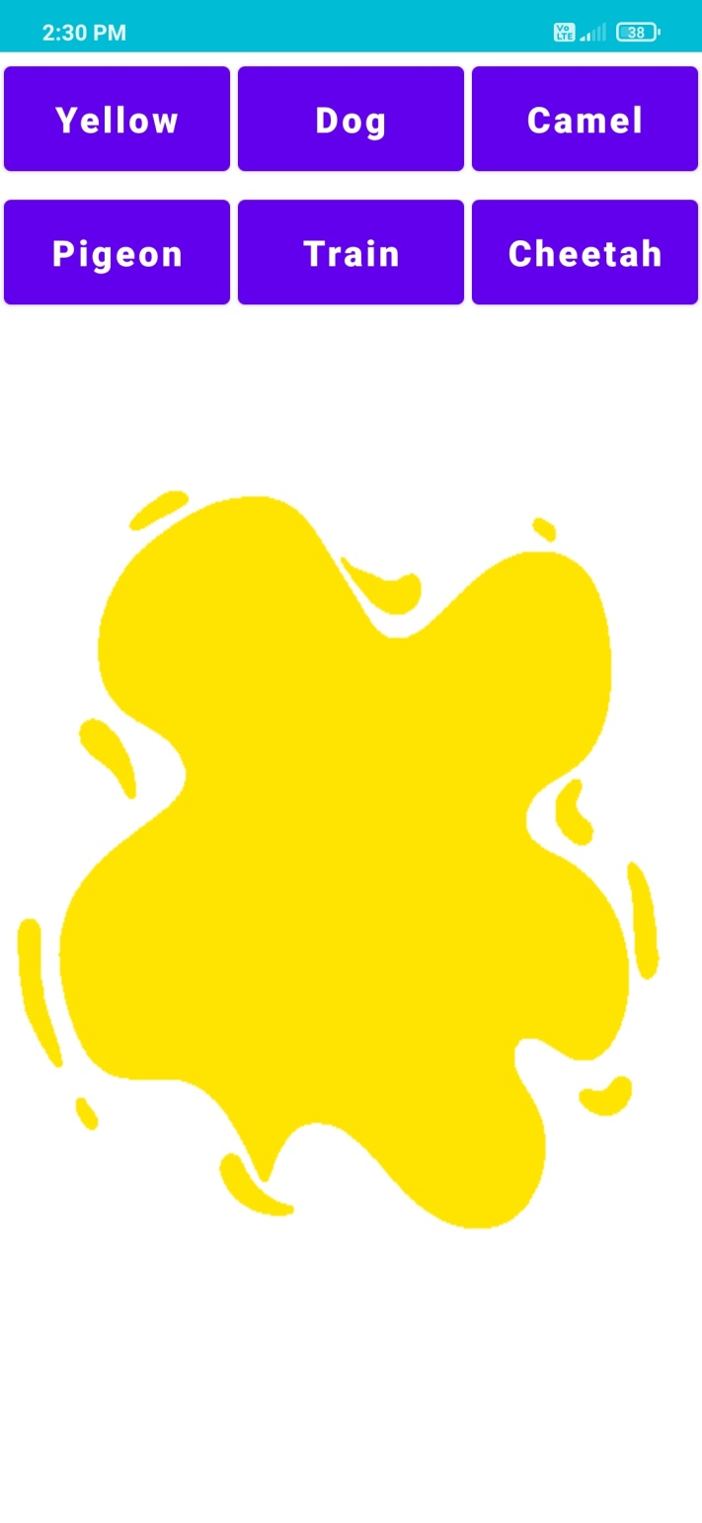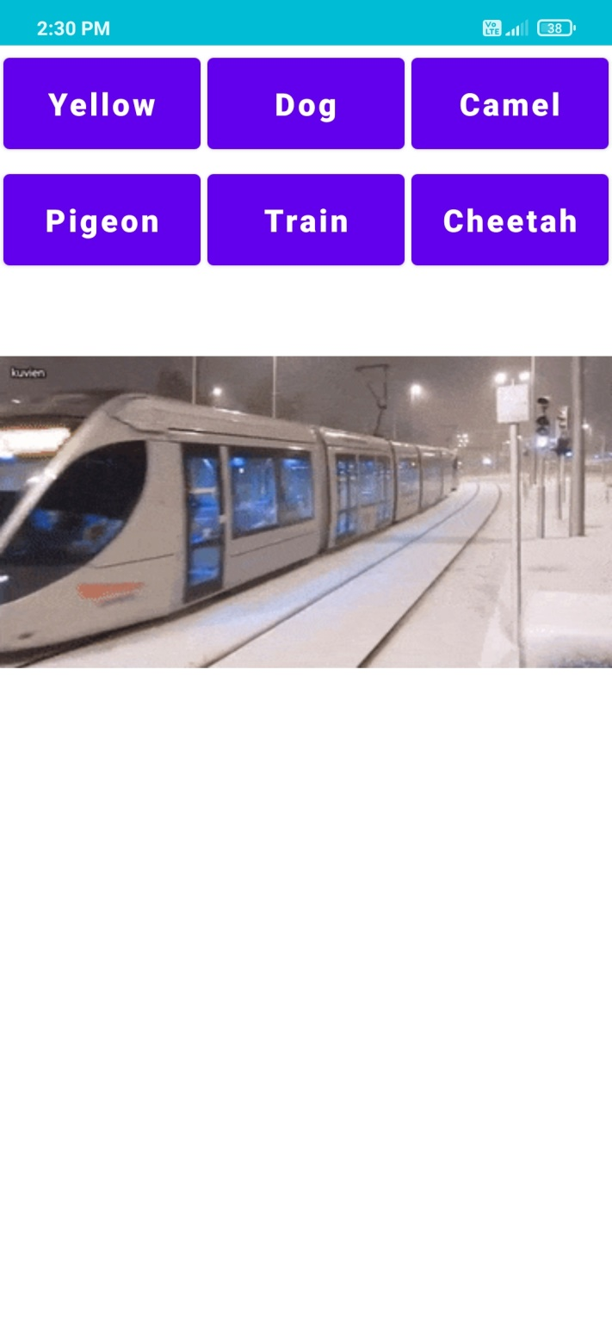 Fig 4.19 GIF screen 2 Fig 4.20 GIF Screen 3

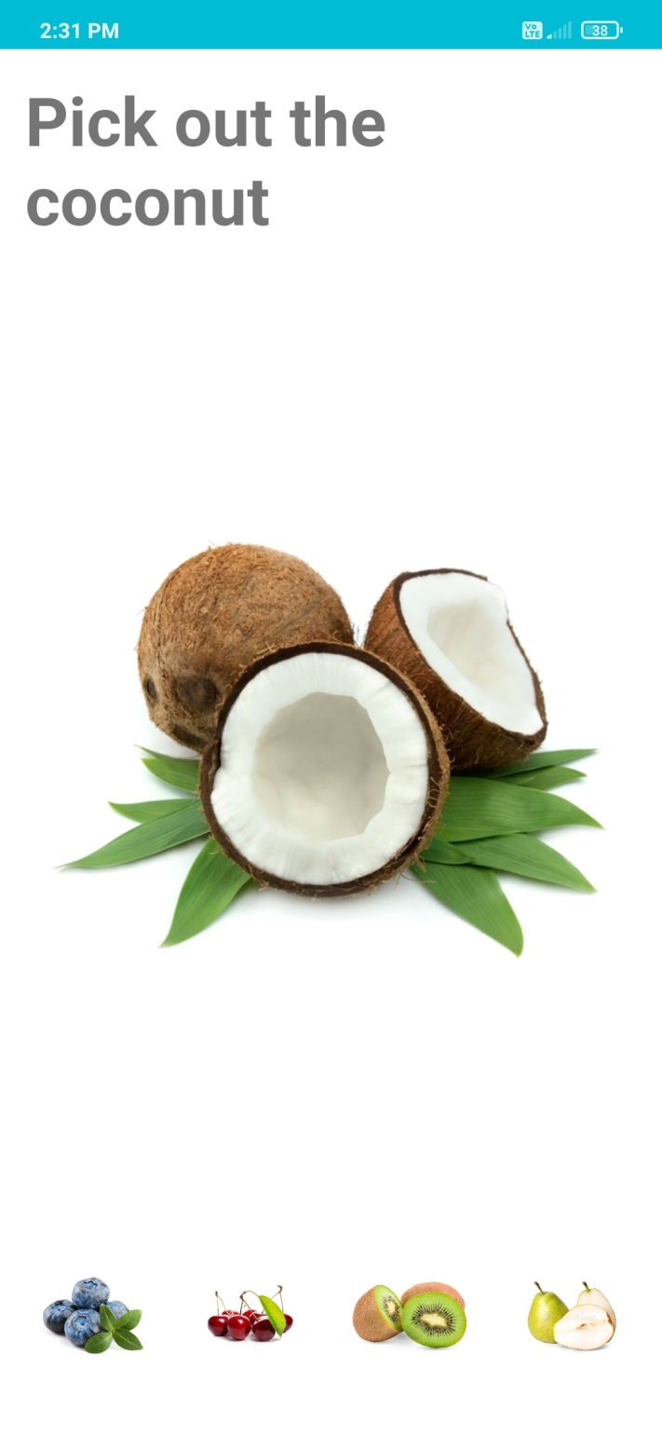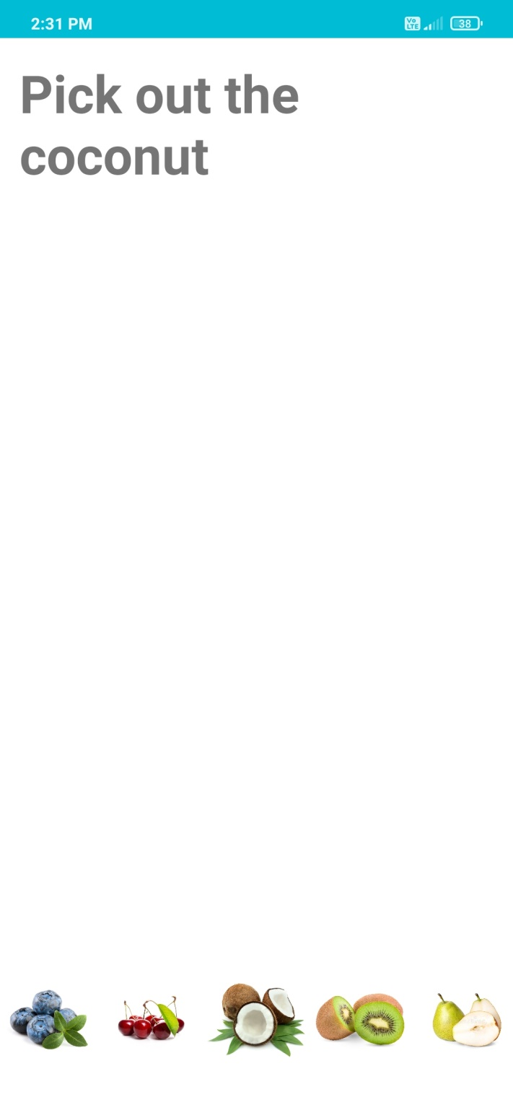 Fig 4.21 Animation 1 screen 1 Fig 4.22 Animation 1 Screen 2

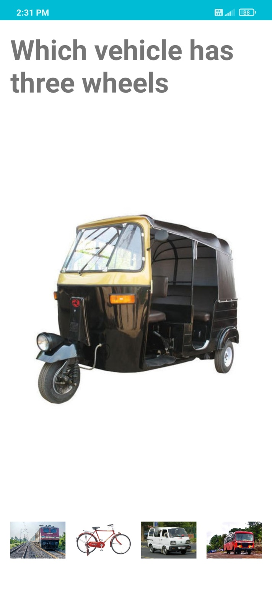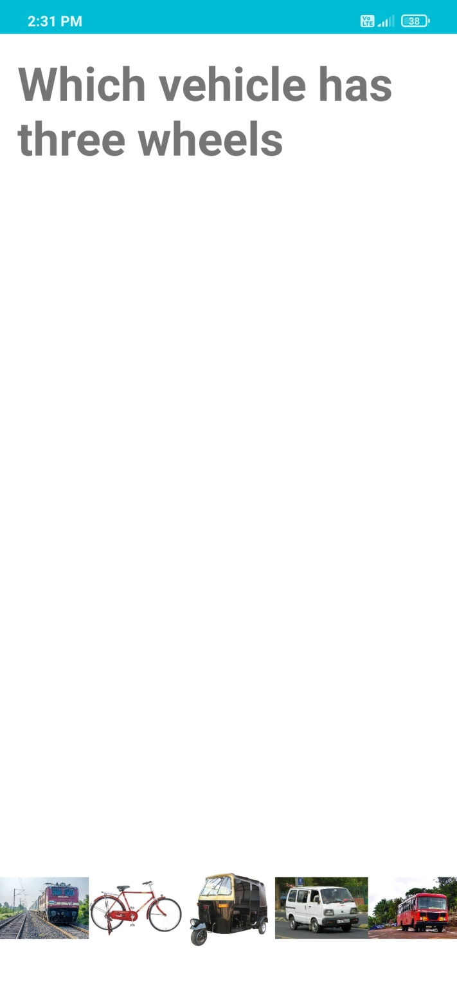 Fig 4.23 Animation 2 screen 1 Fig 4.24 Animation 2 screen 2

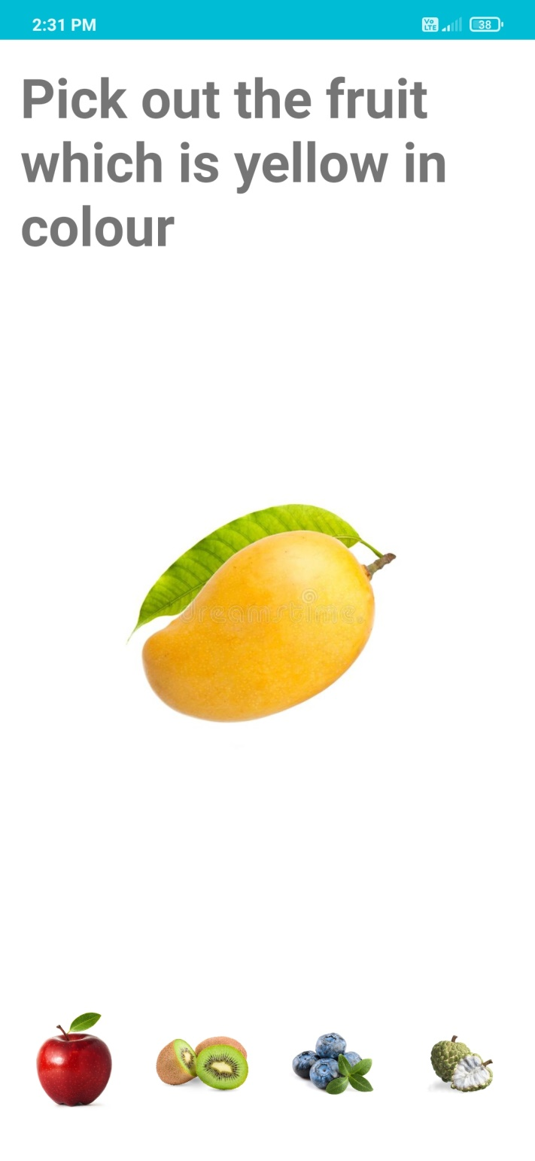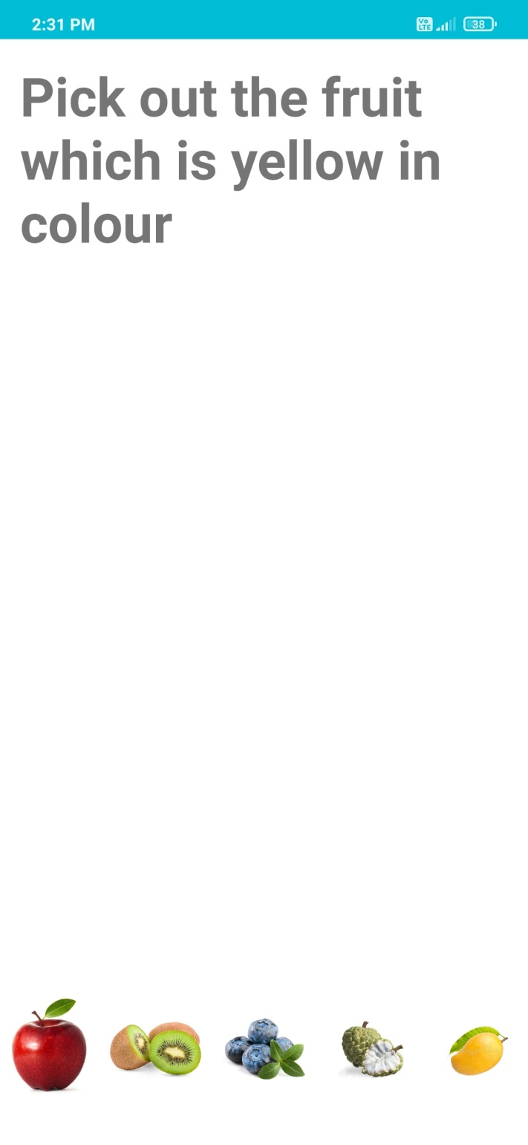 Fig 4.25 Animation 3 screen 1 Fig 4.26 Animation 3 screen 2

* 1. CODE DETAILS

**activity_main.xml**

<?xml version="1.0" encoding="utf-8"?>  
<RelativeLayout xmlns:android="http://schemas.android.com/apk/res/android"  
 xmlns:app="http://schemas.android.com/apk/res-auto"  
 xmlns:tools="http://schemas.android.com/tools"  
 android:layout_width="match_parent"  
 android:layout_height="match_parent"  
 android:orientation="vertical"  
 android:background="@drawable/background"  
 tools:context=".MainActivity">  
  
 <TextView  
 android:id="@+id/heading"  
 android:layout_width="match_parent"  
 android:layout_height="wrap_content"  
 android:padding="5dp"  
 android:text="Kids Learning App"  
 android:textAlignment="center"  
 android:textColor="#FF9800"  
 android:textSize="40sp"  
 android:textStyle="bold|italic" />  
  
 <ScrollView  
 android:layout_width="match_parent"  
 android:layout_height="match_parent"  
 android:layout_below="@id/heading">  
  
 <GridLayout  
 android:layout_width="match_parent"  
 android:layout_height="match_parent"  
 android:rowCount="12"  
 android:columnCount="1">  
  
 <androidx.cardview.widget.CardView  
 android:id="@+id/alphabets"  
 android:layout_width="wrap_content"  
 android:layout_height="wrap_content"  
 android:layout_row="0"  
 android:layout_column="0"  
 android:layout_gravity="fill"  
 android:layout_rowWeight="1"  
 android:layout_marginLeft="15dp"  
 android:layout_marginRight="15dp"  
 android:layout_marginTop="15dp"  
 android:layout_marginBottom="5dp"  
 app:cardElevation="8dp"  
 app:cardCornerRadius="15dp"  
 android:layout_columnWeight="1">  
  
 <LinearLayout  
 android:layout_width="match_parent"  
 android:layout_height="wrap_content"  
 android:orientation="vertical"  
 android:backgroundTintMode="src_in"  
 android:gravity="center"  
 android:layout_gravity="center_vertical|center_horizontal">  
  
 <ImageView  
 android:layout_width="match_parent"  
 android:layout_height="175dp"  
 android:background="@raw/alphabets"/>  
  
 <TextView  
 android:layout_width="match_parent"  
 android:layout_height="wrap_content"  
 android:text="Alphabets"  
 android:gravity="center"  
 android:textColor="#FFFFFF"  
 android:background="#6A6A6A"  
 android:textSize="45sp"  
 android:textStyle="bold"/>  
  
 </LinearLayout>  
  
 </androidx.cardview.widget.CardView>  
  
 <androidx.cardview.widget.CardView  
 android:id="@+id/numbers"  
 android:layout_width="wrap_content"  
 android:layout_height="wrap_content"  
 android:layout_row="1"  
 android:layout_column="0"  
 android:layout_gravity="fill"  
 android:layout_rowWeight="1"  
 android:layout_marginLeft="15dp"  
 android:layout_marginRight="15dp"  
 android:layout_marginTop="5dp"  
 android:layout_marginBottom="5dp"  
 app:cardElevation="8dp"  
 app:cardCornerRadius="15dp"  
 android:layout_columnWeight="1">  
  
 <LinearLayout  
 android:layout_width="match_parent"  
 android:layout_height="wrap_content"  
 android:orientation="vertical"  
 android:backgroundTintMode="src_in"  
 android:gravity="center"  
 android:layout_gravity="center_vertical|center_horizontal">  
  
 <ImageView  
 android:layout_width="match_parent"  
 android:layout_height="175dp"  
 android:background="@raw/numbers"/>  
  
 <TextView  
 android:layout_width="match_parent"  
 android:layout_height="wrap_content"  
 android:text="Numbers"  
 android:gravity="center"  
 android:textColor="#FFFFFF"  
 android:background="#6A6A6A"  
 android:textSize="45sp"  
 android:textStyle="bold"/>  
  
 </LinearLayout>  
  
 </androidx.cardview.widget.CardView>  
  
 <androidx.cardview.widget.CardView  
 android:id="@+id/d_animals"  
 android:layout_width="wrap_content"  
 android:layout_height="wrap_content"  
 android:layout_row="2"  
 android:layout_column="0"  
 android:layout_gravity="fill"  
 android:layout_rowWeight="1"  
 android:layout_marginLeft="15dp"  
 android:layout_marginRight="15dp"  
 android:layout_marginTop="5dp"  
 android:layout_marginBottom="5dp"  
 app:cardElevation="8dp"  
 app:cardCornerRadius="15dp"  
 android:layout_columnWeight="1">  
  
 <LinearLayout  
 android:layout_width="match_parent"  
 android:layout_height="wrap_content"  
 android:orientation="vertical"  
 android:backgroundTintMode="src_in"  
 android:gravity="center"  
 android:layout_gravity="center_vertical|center_horizontal">  
  
 <ImageView  
 android:layout_width="match_parent"  
 android:layout_height="175dp"  
 android:background="@raw/domestic_animals"/>  
  
 <TextView  
 android:layout_width="match_parent"  
 android:layout_height="wrap_content"  
 android:text="Domestic Animals"  
 android:gravity="center"  
 android:textColor="#FFFFFF"  
 android:background="#6A6A6A"  
 android:textSize="40sp"  
 android:textStyle="bold"/>  
  
 </LinearLayout>  
  
 </androidx.cardview.widget.CardView>  
  
 <androidx.cardview.widget.CardView  
 android:id="@+id/w_animals"  
 android:layout_width="wrap_content"  
 android:layout_height="wrap_content"  
 android:layout_row="3"  
 android:layout_column="0"  
 android:layout_gravity="fill"  
 android:layout_rowWeight="1"  
 android:layout_marginLeft="15dp"  
 android:layout_marginRight="15dp"  
 android:layout_marginTop="5dp"  
 android:layout_marginBottom="5dp"  
 app:cardElevation="8dp"  
 app:cardCornerRadius="15dp"  
 android:layout_columnWeight="1">  
  
 <LinearLayout  
 android:layout_width="match_parent"  
 android:layout_height="wrap_content"  
 android:orientation="vertical"  
 android:backgroundTintMode="src_in"  
 android:gravity="center"  
 android:layout_gravity="center_vertical|center_horizontal">  
  
 <ImageView  
 android:layout_width="match_parent"  
 android:layout_height="175dp"  
 android:background="@raw/wild_animals"/>  
  
 <TextView  
 android:layout_width="match_parent"  
 android:layout_height="wrap_content"  
 android:text="Wild Animals"  
 android:gravity="center"  
 android:textColor="#FFFFFF"  
 android:background="#6A6A6A"  
 android:textSize="45sp"  
 android:textStyle="bold"/>  
  
 </LinearLayout>  
  
 </androidx.cardview.widget.CardView>  
  
 <androidx.cardview.widget.CardView  
 android:id="@+id/birds"  
 android:layout_width="wrap_content"  
 android:layout_height="wrap_content"  
 android:layout_row="4"  
 android:layout_column="0"  
 android:layout_gravity="fill"  
 android:layout_rowWeight="1"  
 android:layout_marginLeft="15dp"  
 android:layout_marginRight="15dp"  
 android:layout_marginTop="5dp"  
 android:layout_marginBottom="5dp"  
 app:cardElevation="8dp"  
 app:cardCornerRadius="15dp"  
 android:layout_columnWeight="1">  
  
 <LinearLayout  
 android:layout_width="match_parent"  
 android:layout_height="wrap_content"  
 android:orientation="vertical"  
 android:backgroundTintMode="src_in"  
 android:gravity="center"  
 android:layout_gravity="center_vertical|center_horizontal">  
  
 <ImageView  
 android:layout_width="match_parent"  
 android:layout_height="175dp"  
 android:background="@raw/birds"/>  
  
 <TextView  
 android:layout_width="match_parent"  
 android:layout_height="wrap_content"  
 android:text="Birds"  
 android:gravity="center"  
 android:textColor="#FFFFFF"  
 android:background="#6A6A6A"  
 android:textSize="45sp"  
 android:textStyle="bold"/>  
  
 </LinearLayout>  
  
 </androidx.cardview.widget.CardView>  
  
 <androidx.cardview.widget.CardView  
 android:id="@+id/fruits"  
 android:layout_width="wrap_content"  
 android:layout_height="wrap_content"  
 android:layout_row="5"  
 android:layout_column="0"  
 android:layout_gravity="fill"  
 android:layout_rowWeight="1"  
 android:layout_marginLeft="15dp"  
 android:layout_marginRight="15dp"  
 android:layout_marginTop="5dp"  
 android:layout_marginBottom="5dp"  
 app:cardElevation="8dp"  
 app:cardCornerRadius="15dp"  
 android:layout_columnWeight="1">  
  
 <LinearLayout  
 android:layout_width="match_parent"  
 android:layout_height="wrap_content"  
 android:orientation="vertical"  
 android:backgroundTintMode="src_in"  
 android:gravity="center"  
 android:layout_gravity="center_vertical|center_horizontal">  
  
 <ImageView  
 android:layout_width="match_parent"  
 android:layout_height="175dp"  
 android:background="@raw/fruits"/>  
  
 <TextView  
 android:layout_width="match_parent"  
 android:layout_height="wrap_content"  
 android:text="Fruits"  
 android:gravity="center"  
 android:textColor="#FFFFFF"  
 android:background="#6A6A6A"  
 android:textSize="45sp"  
 android:textStyle="bold"/>  
  
 </LinearLayout>  
  
 </androidx.cardview.widget.CardView>  
  
 <androidx.cardview.widget.CardView  
 android:id="@+id/vegetables"  
 android:layout_width="wrap_content"  
 android:layout_height="wrap_content"  
 android:layout_row="6"  
 android:layout_column="0"  
 android:layout_gravity="fill"  
 android:layout_rowWeight="1"  
 android:layout_marginLeft="15dp"  
 android:layout_marginRight="15dp"  
 android:layout_marginTop="5dp"  
 android:layout_marginBottom="5dp"  
 app:cardElevation="8dp"  
 app:cardCornerRadius="15dp"  
 android:layout_columnWeight="1">  
  
 <LinearLayout  
 android:layout_width="match_parent"  
 android:layout_height="wrap_content"  
 android:orientation="vertical"  
 android:backgroundTintMode="src_in"  
 android:gravity="center"  
 android:layout_gravity="center_vertical|center_horizontal">  
  
 <ImageView  
 android:layout_width="match_parent"  
 android:layout_height="175dp"  
 android:background="@raw/vegetables"/>  
  
 <TextView  
 android:layout_width="match_parent"  
 android:layout_height="wrap_content"  
 android:text="Vegetables"  
 android:gravity="center"  
 android:textColor="#FFFFFF"  
 android:background="#6A6A6A"  
 android:textSize="45sp"  
 android:textStyle="bold"/>  
  
 </LinearLayout>  
  
 </androidx.cardview.widget.CardView>  
  
 <androidx.cardview.widget.CardView  
 android:id="@+id/vehicles"  
 android:layout_width="wrap_content"  
 android:layout_height="wrap_content"  
 android:layout_row="7"  
 android:layout_column="0"  
 android:layout_gravity="fill"  
 android:layout_rowWeight="1"  
 android:layout_marginLeft="15dp"  
 android:layout_marginRight="15dp"  
 android:layout_marginTop="5dp"  
 android:layout_marginBottom="5dp"  
 app:cardElevation="8dp"  
 app:cardCornerRadius="15dp"  
 android:layout_columnWeight="1">  
  
 <LinearLayout  
 android:layout_width="match_parent"  
 android:layout_height="wrap_content"  
 android:orientation="vertical"  
 android:backgroundTintMode="src_in"  
 android:gravity="center"  
 android:layout_gravity="center_vertical|center_horizontal">  
  
 <ImageView  
 android:layout_width="match_parent"  
 android:layout_height="175dp"  
 android:background="@raw/vehicles"/>  
  
 <TextView  
 android:layout_width="match_parent"  
 android:layout_height="wrap_content"  
 android:text="Vehicles"  
 android:gravity="center"  
 android:textColor="#FFFFFF"  
 android:background="#6A6A6A"  
 android:textSize="45sp"  
 android:textStyle="bold"/>  
  
 </LinearLayout>  
  
 </androidx.cardview.widget.CardView>  
  
 <androidx.cardview.widget.CardView  
 android:id="@+id/rhymes"  
 android:layout_width="wrap_content"  
 android:layout_height="wrap_content"  
 android:layout_row="8"  
 android:layout_column="0"  
 android:layout_gravity="fill"  
 android:layout_rowWeight="1"  
 android:layout_marginLeft="15dp"  
 android:layout_marginRight="15dp"  
 android:layout_marginTop="5dp"  
 android:layout_marginBottom="5dp"  
 app:cardElevation="8dp"  
 app:cardCornerRadius="15dp"  
 android:layout_columnWeight="1">  
  
 <LinearLayout  
 android:layout_width="match_parent"  
 android:layout_height="wrap_content"  
 android:orientation="vertical"  
 android:backgroundTintMode="src_in"  
 android:gravity="center"  
 android:layout_gravity="center_vertical|center_horizontal">  
  
 <ImageView  
 android:layout_width="match_parent"  
 android:layout_height="175dp"  
 android:background="@raw/rhymes"/>  
  
 <TextView  
 android:layout_width="match_parent"  
 android:layout_height="wrap_content"  
 android:text="Rhymes"  
 android:gravity="center"  
 android:textColor="#FFFFFF"  
 android:background="#6A6A6A"  
 android:textSize="45sp"  
 android:textStyle="bold"/>  
  
 </LinearLayout>  
  
 </androidx.cardview.widget.CardView>  
  
 <androidx.cardview.widget.CardView  
 android:id="@+id/colours"  
 android:layout_width="wrap_content"  
 android:layout_height="wrap_content"  
 android:layout_row="9"  
 android:layout_column="0"  
 android:layout_gravity="fill"  
 android:layout_rowWeight="1"  
 android:layout_marginLeft="15dp"  
 android:layout_marginRight="15dp"  
 android:layout_marginTop="5dp"  
 android:layout_marginBottom="5dp"  
 app:cardElevation="8dp"  
 app:cardCornerRadius="15dp"  
 android:layout_columnWeight="1">  
  
 <LinearLayout  
 android:layout_width="match_parent"  
 android:layout_height="wrap_content"  
 android:orientation="vertical"  
 android:backgroundTintMode="src_in"  
 android:gravity="center"  
 android:layout_gravity="center_vertical|center_horizontal">  
  
 <ImageView  
 android:layout_width="match_parent"  
 android:layout_height="175dp"  
 android:background="@raw/colours"/>  
  
 <TextView  
 android:layout_width="match_parent"  
 android:layout_height="wrap_content"  
 android:text="Colours"  
 android:gravity="center"  
 android:textColor="#FFFFFF"  
 android:background="#6A6A6A"  
 android:textSize="45sp"  
 android:textStyle="bold"/>  
  
 </LinearLayout>  
  
 </androidx.cardview.widget.CardView>  
  
 <androidx.cardview.widget.CardView  
 android:id="@+id/test"  
 android:layout_width="wrap_content"  
 android:layout_height="wrap_content"  
 android:layout_row="10"  
 android:layout_column="0"  
 android:layout_gravity="fill"  
 android:layout_rowWeight="1"  
 android:layout_marginLeft="15dp"  
 android:layout_marginRight="15dp"  
 android:layout_marginTop="5dp"  
 android:layout_marginBottom="5dp"  
 app:cardElevation="8dp"  
 app:cardCornerRadius="15dp"  
 android:layout_columnWeight="1">  
  
 <LinearLayout  
 android:layout_width="match_parent"  
 android:layout_height="wrap_content"  
 android:orientation="vertical"  
 android:backgroundTintMode="src_in"  
 android:gravity="center"  
 android:layout_gravity="center_vertical|center_horizontal">  
  
 <ImageView  
 android:layout_width="match_parent"  
 android:layout_height="175dp"  
 android:background="@raw/activity_image"/>  
  
 <TextView  
 android:layout_width="match_parent"  
 android:layout_height="wrap_content"  
 android:text="Activities"  
 android:gravity="center"  
 android:textColor="#FFFFFF"  
 android:background="#6A6A6A"  
 android:textSize="45sp"  
 android:textStyle="bold"/>  
  
 </LinearLayout>  
  
 </androidx.cardview.widget.CardView>  
  
 <androidx.cardview.widget.CardView  
 android:id="@+id/fun_learning"  
 android:layout_width="wrap_content"  
 android:layout_height="wrap_content"  
 android:layout_row="11"  
 android:layout_column="0"  
 android:layout_gravity="fill"  
 android:layout_rowWeight="1"  
 android:layout_marginLeft="15dp"  
 android:layout_marginRight="15dp"  
 android:layout_marginTop="5dp"  
 android:layout_marginBottom="15dp"  
 app:cardElevation="8dp"  
 app:cardCornerRadius="15dp"  
 android:layout_columnWeight="1">  
  
 <LinearLayout  
 android:layout_width="match_parent"  
 android:layout_height="wrap_content"  
 android:orientation="vertical"  
 android:backgroundTintMode="src_in"  
 android:gravity="center"  
 android:layout_gravity="center_vertical|center_horizontal">  
  
 <ImageView  
 android:layout_width="match_parent"  
 android:layout_height="175dp"  
 android:background="@raw/funlearn_image"/>  
  
 <TextView  
 android:layout_width="match_parent"  
 android:layout_height="wrap_content"  
 android:text="Tricky,Fun,Craze"  
 android:gravity="center"  
 android:textColor="#FFFFFF"  
 android:background="#6A6A6A"  
 android:textSize="35sp"  
 android:textStyle="bold"/>  
  
 </LinearLayout>  
  
 </androidx.cardview.widget.CardView>  
  
 </GridLayout>  
  
 </ScrollView>  
  
</RelativeLayout>

**MainActivity.java**

package com.example.kidslearningapp;  
  
import androidx.appcompat.app.AppCompatActivity;  
import androidx.cardview.widget.CardView;  
  
import android.content.Intent;  
import android.os.Bundle;  
import android.view.View;  
  
public class MainActivity extends AppCompatActivity {  
  
 CardView alphabets,numbers,d_animals,w_animals,birds,fruits,vegetables,vehicles,rhymes,colours,test,fun_learning;  
  
 @Override  
 protected void onCreate(Bundle savedInstanceState) {  
 super.onCreate(savedInstanceState);  
 setContentView(R.layout.*activity_main*);  
  
 alphabets = findViewById(R.id.*alphabets*);  
 numbers = findViewById(R.id.*numbers*);  
 d_animals = findViewById(R.id.*d_animals*);  
 w_animals = findViewById(R.id.*w_animals*);  
 birds = findViewById(R.id.*birds*);  
 fruits = findViewById(R.id.*fruits*);  
 vegetables = findViewById(R.id.*vegetables*);  
 vehicles = findViewById(R.id.*vehicles*);  
 rhymes = findViewById(R.id.*rhymes*);  
 colours = findViewById(R.id.*colours*);  
 test = findViewById(R.id.*test*);  
 fun_learning = findViewById(R.id.*fun_learning*);  
  
  
 alphabets.setOnClickListener(new View.OnClickListener() {  
 @Override  
 public void onClick(View view) {  
 Intent intent = new Intent(MainActivity.this,Alphabets.class);  
 startActivity(intent);  
 }  
 });  
  
 numbers.setOnClickListener(new View.OnClickListener() {  
 @Override  
 public void onClick(View view) {  
 Intent intent = new Intent(MainActivity.this,Numbers.class);  
 startActivity(intent);  
 }  
 });  
  
 d_animals.setOnClickListener(new View.OnClickListener() {  
 @Override  
 public void onClick(View view) {  
 Intent intent = new Intent(MainActivity.this,Domestic_Animals.class);  
 startActivity(intent);  
 }  
 });  
  
 w_animals.setOnClickListener(new View.OnClickListener() {  
 @Override  
 public void onClick(View view) {  
 Intent intent = new Intent(MainActivity.this,Wild_Animals.class);  
 startActivity(intent);  
 }  
 });  
  
 birds.setOnClickListener(new View.OnClickListener() {  
 @Override  
 public void onClick(View view) {  
 Intent intent = new Intent(MainActivity.this,Birds.class);  
 startActivity(intent);  
 }  
 });  
  
 fruits.setOnClickListener(new View.OnClickListener() {  
 @Override  
 public void onClick(View view) {  
 Intent intent = new Intent(MainActivity.this,Fruits.class);  
 startActivity(intent);  
 }  
 });  
  
 vegetables.setOnClickListener(new View.OnClickListener() {  
 @Override  
 public void onClick(View view) {  
 Intent intent = new Intent(MainActivity.this,Vegetables.class);  
 startActivity(intent);  
 }  
 });  
  
 vehicles.setOnClickListener(new View.OnClickListener() {  
 @Override  
 public void onClick(View view) {  
 Intent intent = new Intent(MainActivity.this,Vehicles.class);  
 startActivity(intent);  
 }  
 });  
  
 rhymes.setOnClickListener(new View.OnClickListener() {  
 @Override  
 public void onClick(View view) {  
 Intent intent = new Intent(MainActivity.this,Rhymes.class);  
 startActivity(intent);  
 }  
 });  
  
 colours.setOnClickListener(new View.OnClickListener() {  
 @Override  
 public void onClick(View view) {  
 Intent intent = new Intent(MainActivity.this,Colours.class);  
 startActivity(intent);  
 }  
 });  
  
 test.setOnClickListener(new View.OnClickListener() {  
 @Override  
 public void onClick(View view) {  
 Intent intent = new Intent(MainActivity.this,Test.class);  
 startActivity(intent);  
 }  
 });  
  
 fun_learning.setOnClickListener(new View.OnClickListener() {  
 @Override  
 public void onClick(View view) {  
 Intent intent = new Intent(MainActivity.this,Fun.class);  
 startActivity(intent);  
 }  
 });  
  
 }  
}

**AndroidManifest.xml**

<?xml version="1.0" encoding="utf-8"?>  
<manifest xmlns:android="http://schemas.android.com/apk/res/android"  
 package="com.example.kidslearningapp">  
  
 <application  
 android:allowBackup="true"  
 android:icon="@mipmap/ic_launcher"  
 android:label="@string/app_name"  
 android:roundIcon="@mipmap/ic_launcher_round"  
 android:supportsRtl="true"  
 android:theme="@style/Theme.KidsLearningApp">  
 <activity  
 android:name=".Anim5"  
 android:exported="false" />  
 <activity  
 android:name=".Anim4"  
 android:exported="false" />  
 <activity  
 android:name=".Anim3"  
 android:exported="false" />  
 <activity  
 android:name=".Anim2"  
 android:exported="false" />  
 <activity  
 android:name=".Anim1"  
 android:exported="false" />  
 <activity  
 android:name=".Gif"  
 android:exported="false" />  
 <activity  
 android:name=".Fun"  
 android:exported="false" />  
 <activity  
 android:name=".Test"  
 android:exported="false" />  
 <activity  
 android:name=".Colours"  
 android:exported="false" />  
 <activity  
 android:name=".Rhymes"  
 android:exported="false" />  
 <activity  
 android:name=".Wild_Animals"  
 android:exported="false" />  
 <activity  
 android:name=".Vehicles"  
 android:exported="false" />  
 <activity  
 android:name=".Vegetables"  
 android:exported="false" />  
 <activity  
 android:name=".Numbers"  
 android:exported="false" />  
 <activity  
 android:name=".Fruits"  
 android:exported="false" />  
 <activity  
 android:name=".Domestic_Animals"  
 android:exported="false" />  
 <activity  
 android:name=".Birds"  
 android:exported="false" />  
 <activity  
 android:name=".Alphabets"  
 android:exported="false" />  
 <activity  
 android:name=".MainActivity"  
 android:exported="true">  
 <intent-filter>  
 <action android:name="android.intent.action.MAIN" />  
 <category android:name="android.intent.category.LAUNCHER" />  
 </intent-filter>  
 </activity>  
 </application>  
  
</manifest>

1. **PROJECT TESTING**
   1. UNIT TESTING

Unit testing fouces first on modules,independetly of one another to locate error. This enables the tester in coding and logic that contained within module alone.those resulting from intergration between modules are initally avoided in this testing individual programs were run and sample data was fed so to check whether the desire output was achieved or not.

* 1. SYSTEM TESTING

Tab 5.1 TESTING

|  |  |  |  |  |  |  |
| --- | --- | --- | --- | --- | --- | --- |
| Test case ID | Test Case Description | Steps | Test data Input | Expected Result | Actual Result | Status |
| 1 | Launch Application | Open App | **−** | Application should Launch Successfully | Application Launched Successfully | Pass |
| 2 | User must interact with related activity when user clicked on CardView. | 1] Open App  2] Click on alphabets | **−** | User should interact with related activity when user clicked on CardView. | User interacted with related activity when user clicked on CardView. | Pass |
| 3 | User must hear sounds related to clicked all types of control | 1] Open App  2] Click on any CardView  3] Click on any control | **−** | User should hear sounds related to clicked all types of control | User heard sounds related to clicked all types of control | Pass |
| 4 | User must view and hear rhymes when user clicked on rhymes | 1] Open App  2] Click on Rhymes CardView  3] Click on Rhymes | **−** | User should view and hear rhymes when user clicked on rhymes | User viewed and heard rhymes when user clicked on rhymes | Pass |
| 5 | Application must tell whether the answer is correct or not | 1] Open App  2] Click on Activities CardView  3] Click on any Control | **−** | Application should tell whether the answer is correct or not | Application told successfully whether the answer is correct or not | Pass |
| 6 | User must able to see GIF’s when user clicked on gif Button | 1] Open App  2] Click on Fun, Craze CardView  3] Click on GIF control  4] Click on any button | **−** | User should able to see GIF’s when user clicked on gif Button | User saw GIF’s  successfully when user clicked on gif Button | Pass |
| 7 | User must able to see Animation’s when user clicked on options Button | 1] Open App  2] Click on Fun, Craze CardView  3] Click on any activity control  4] Click on any option | **−** | User should able to see Animation’s when user clicked on options Button | User saw Animation’s successfully when user clicked on options Button | Pass |

1. **CONCLUSIONS**

We have successfully completed the Project titled “Kids Learning App” under the Guidence of Mrs. Trigule D.J.

1. **BIBLIOGRAPHY**

* <https://mixkit.co/free-sound-effects/cat/>
* <https://mobcup.net/browse/ringtones/mp3/0/downloads/cat-sound>
* <https://www.youtube.com/results?search_query=a+for+apple>
* <https://www.youtube.com/results?search_query=popular+rhymes>